**RESUME**

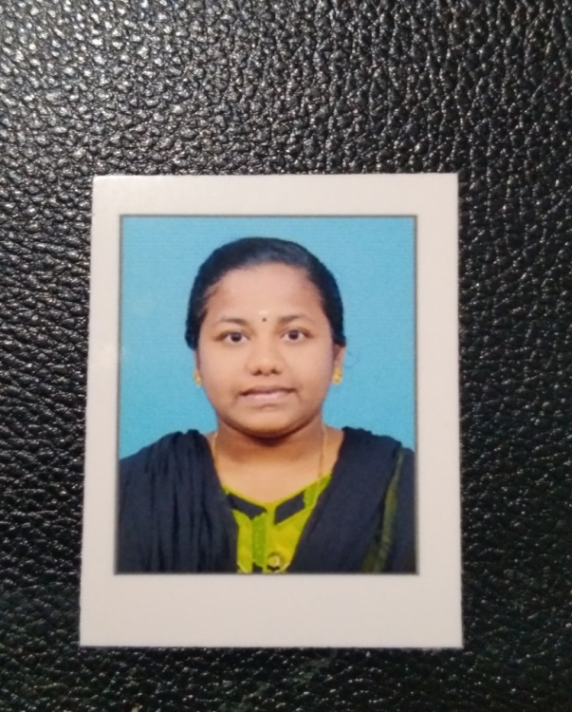

**Name : AATHISAKTHIMARI C**

**DOB :** 04/07/2004

**Gender :** Female

**Father's Name :**  A. CHERMAKANI

**Address :** D/o :A. Chermakani,1/202, South Street,Ramachandrapattanam,Tenkasi district -627 814.

**Email ID : [aathisakthimari@gmail.com](mailto:aathisakthimari@gmail.com)**

**Phone number :** 9342107928

**Marital status :** Unmarried

**Nationality :** Indian

**Religion**  : Hindu

**Objective:**

Seeking a challenging position in a reputed organization where I can learn new skills, expand my knowledge and leverage my learning. If you give chance to me, I will prove my worthy of selection.

**Educational qualifications:**

* SSLC **: 84.4 % (2019)**
* HSC  **: 87.38 % (2021)**
* Bachelor of computer science (2nd year)

(Govt. Arts & Science College for women, Alangulam)

* Typewriting **: English Junior**
* Course **: M.S. Office & Yoga**
* Language known **: Tamil & English**

**Key strength:**

* **Improving own learning and performance.**
* **Good communication skill.**
* **Flexibility in adapting new things.**
* **Good creative skill.**
* **Ability to understand anything.**

**Declaration:**

**I hereby declare that all the details given below are true to the best of my knowledge and belief**.

**Place:** Ramachandrapattanam **Signature**

**Date:** 19th March 2023 (AATHISAKTHIMARI C)